Algebra 1: Unit 4, Lesson 7

- The graph of function $f(x)$, is shown.
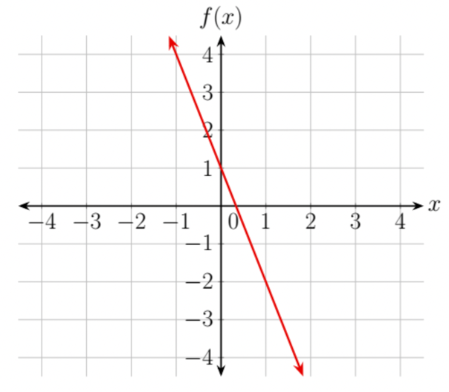
What is the solution to $f\left(x\right)=-2$?
1
$x=$ ____________

- The function, $h\left(x\right)=2x-5$, models the height, ℎ, in feet, of a tree, where $x$ is the age of the tree, in years. What is the height of the tree that is 17 years old?
29 feet

- Joan has $65 to buy her friends a gift bag. The gift bags are $5 each. The function, $f\left(x\right)=-5x+65$, represents the amount of money Joan has left in her budget after purchasing x gift bags.
The solution for $f\left(x\right)=0$ is $x=$ ______.
13

